VOTE FOR
AFFORDABLE HOUSING
A pop up! Open Mic!
Speak with people and politicians!

Weekdays 8:00 a.m. to 8:20 a.m
September 13 to September 17
At the Dundas West subway station
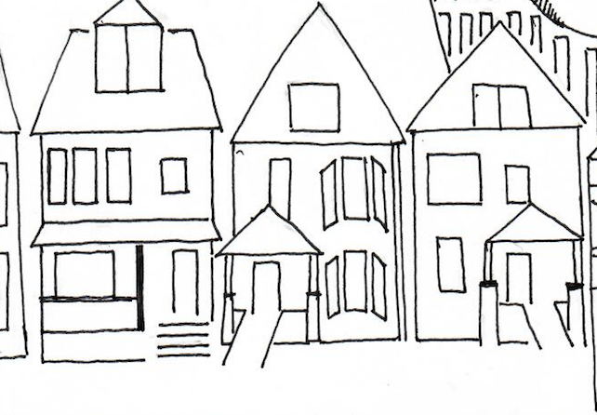

Contact: 647-781-6225

